FUNCTION MACHINES
OCR GSCE – Monday 9 November 2020 – Paper 6 (Calculator) Higher Tier
1.
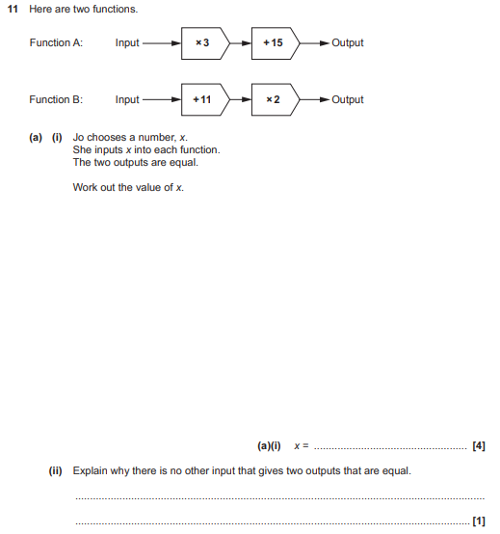
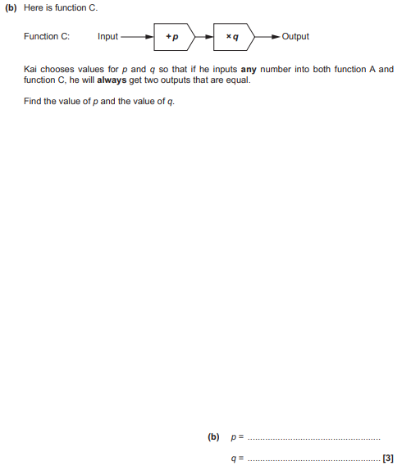

OCR GSCE – Tuesday 5 November 2019 – Paper 4 (Calculator) Higher Tier
2.
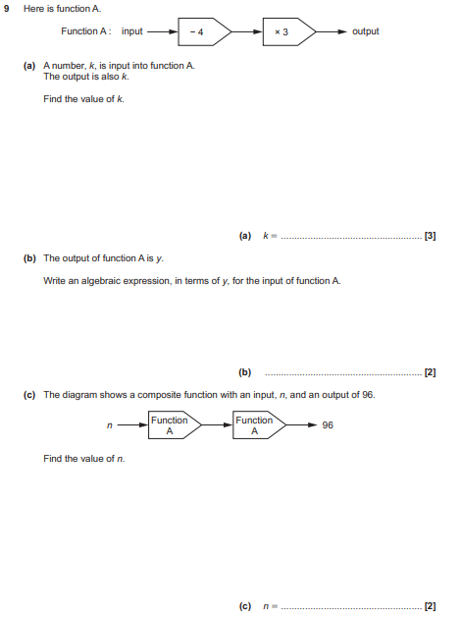

OCR GSCE – Thursday 6 June 2019 – Paper 5 (Non-Calculator) Higher Tier
3.
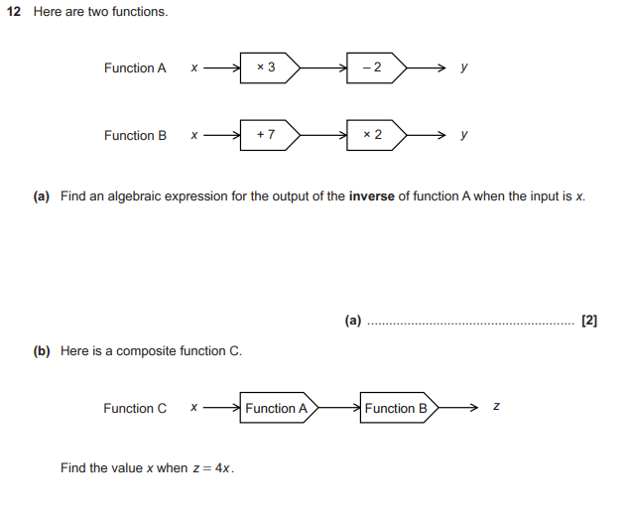

OCR GSCE – Tuesday 6 November 2018 – Paper 4 (Calculator) Higher Tier
4.
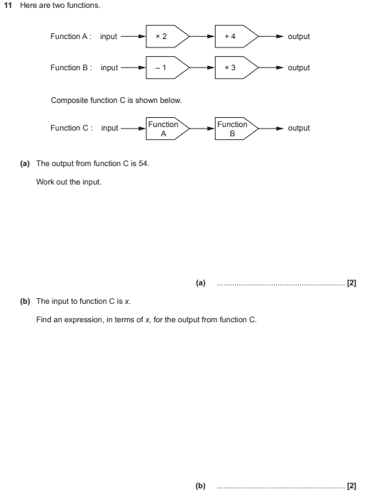

OCR GSCE – Tuesday 12 June 2018 – Paper 6 (Calculator) Higher Tier
5.
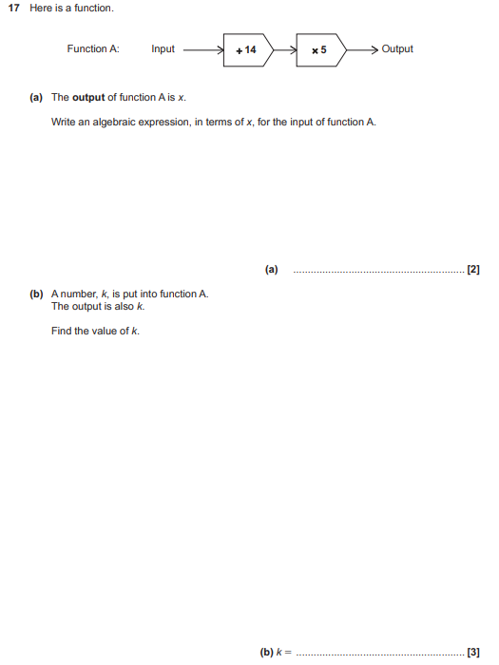

OCR GSCE – Tuesday 13 June 2017 – Paper 6 (Calculator) Higher Tier
6.
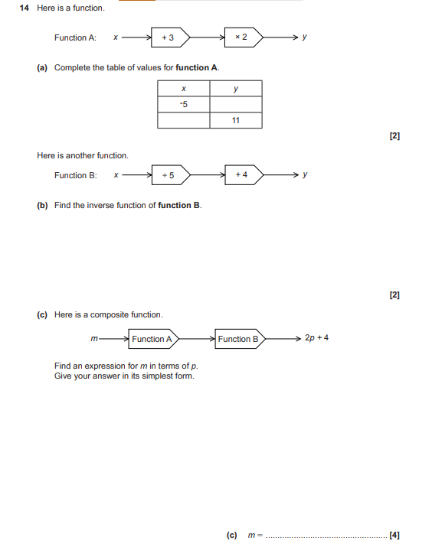

OCR GSCE – Sample Papers – Paper 4 (Calculator) Higher Tier
7.
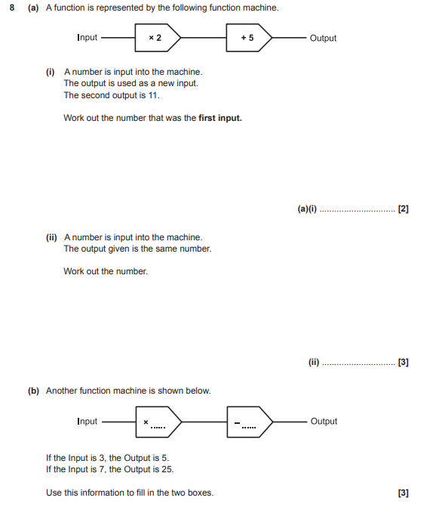

AQA GSCE – Sample Paper 3 (Calculator) Higher Tier
8.
